Introduction to Power BI Desktop
✓ Installing Power BI desktop
✓ Import data from diverse sources
✓ Creating Reports and Dashboards
✓ Adding Charts and Visualizations
Creating reports
▪ Adding pages
▪ Renaming pages
▪ Moving pages
▪ Delete pages
✓ Importing excel and power view items
Discovering and loading data with Power BI Desktop
✓ Data sources
▪ File sources
▪ Databases
▪ SQL Server and other sources
✓ Loading data
▪ Web pages
▪ CSV files
▪ XML files
▪ Excel
✓ Relational databases
▪ Loading related tables
▪ Database options

Transforming datasets (Power Query)
✓ Power BI desktop queries
▪ Editing data after data load
▪ Transforming data
✓ Query editor and ribbons
✓ Dataset shaping
✓ Filtering data
Data cleansing
✓ Changing datatype
✓ Replacing values
✓ Transforming column contents
✓ Grouping records
✓ Pivot
✓ Un pivot
✓ Extending data
▪ Duplicating columns
▪ Splitting columns
▪ Merging columns
▪ Custom columns
▪ Merging data
✓ Appending data
▪ Adding contents of one query to another
▪ Pivoting and un pivoting tables
▪ Transposing rows and columns
✓ Managing queries
▪ Grouping queries
▪ Duplicating queries

Creating a data model
✓ Data modeling in Power BI desktop environment
✓ Data modeling ribbon
✓ Manipulating tables and columns
✓ Sorting data
✓ Designing a data model
▪ Creating relationships
▪ Creating relationships manually/automatically
▪ Deleting relationships
Text based visualizations
✓ Switching to report view
Creating and modifications Charts in Power BI Desktop
✓ Column charts
✓ Line charts
✓ Pie charts
✓ Donut charts
✓ Funnel charts
✓ Water fall charts
Other types of visuals
✓ Maps
✓ Filled maps
✓ Tree maps
✓ Gauges
✓ Matrix table
Filtering data
✓ Visual level filters
✓ Page level filters
✓ Drill through filters
✓ Report level filters

Using slicers
✓ Slicers
✓ Sync slicer
Enhancing dashboards
✓ Text boxes
✓ Modifying Page background
✓ Images
✓ Adding shapes
✓ Organizing visuals on the page
✓ Exporting data from a visualization
✓ Creating Bins
✓ Field formatting
✓ Conditional formatting
✓ Tool tips
✓ Import custom visuals from market place
Row level security (RLS)
✓ Creating Manage roles and View as roles
Creating reports
✓ Parameter report
✓ Hierarchy report
✓ Drill down report
✓ Drill through report
Data analysis expressions (DAX)
✓ New column
✓ Currency column
✓ Lower column
✓ Even column
✓ Odd column
✓ If column
✓ Concatenate column
✓ New measure
✓ Sum measure

DAX Functions for Transformations and Calculations

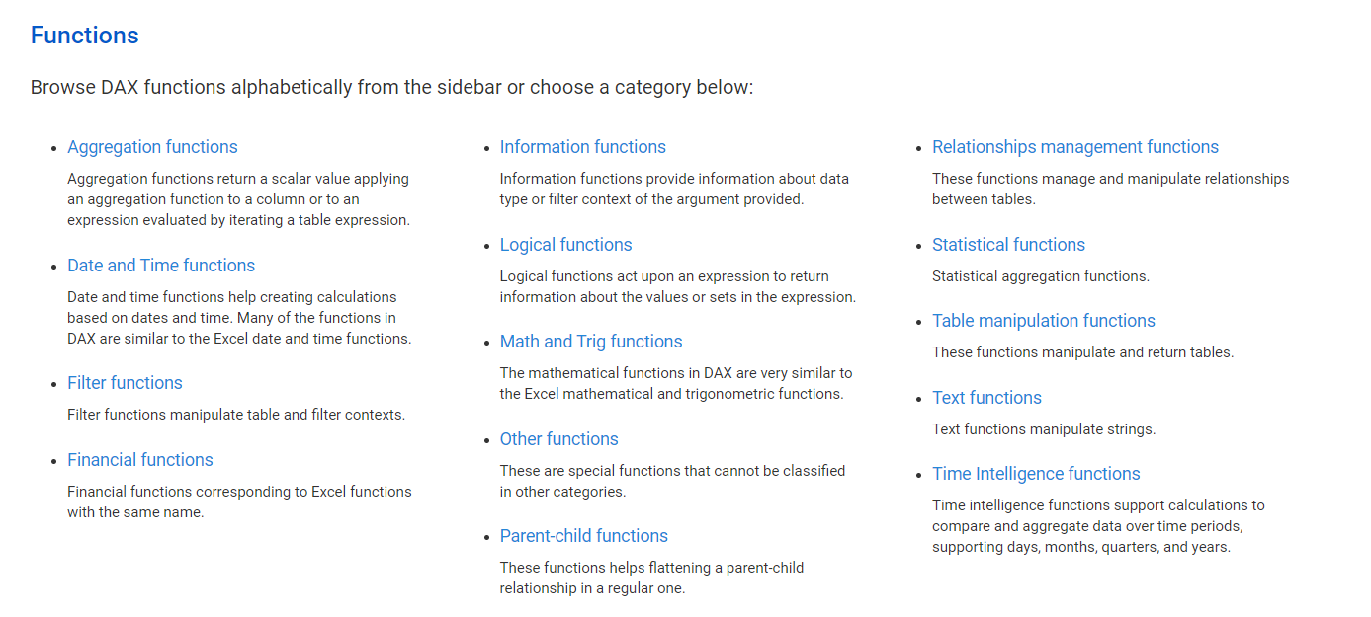
DAX SECURITY
POWER BI SERVICE / WEB
✓ My Work space
✓ APPs Work space
✓ Datasets
✓ Reports
✓ Dashboards
✓ Gateways
✓ Schedule refresh
✓ Q&A
✓ Content packs
✓ Insights
✓ Pin Dashboards
✓ Dashboards theme
✓ Export to excel
✓ Row level security
✓ Embed codes
✓ Alerts
✓ Notifications
✓ Subscriptions
✓ Get data
✓ Create reports
✓ Admin portal
✓ Add title and image
✓ Screen shots
✓ High contrast colors
✓ Generate QR Code

Power BI Report Server

- What is Power BI Report Server? Key Features of Report Server
- The architecture of the Report Server Limitations of Report Server
- Power BI Report Server vs. Power BI Service Acquiring and Installing Power BI Report Server What is a Web Portal?
- Hands-on:
- Using Power BI Report Server for Publishing Reports Implementing Row Level Security
- Skills You will Learn Power BI Report Server
- Publishing reports on Report Server

Power Bi Mobile

